Product Requirements: Chat Flow Orchestration
Product Manager : Elsa Vinietta
Engineering Manager : Rizky Nuredja
Stakeholders : Mochamad Taufiq HidayahSabila Nurul FauziahTommy Saputra
Launch Date (target) : Jul 21, 2026
Link to PM Tool : https://project-roadmap.evermosa2z.com/public/projects/2673056

Version History

Version | Date Change | Changelog Summary
v0.1 | May 29, 2026 | Initial Document

Approval

Created by | Elsa Vinietta(PM)
Reviewed by | M. Reza Mahdar(HoP)
 | Mochamad Taufiq Hidayah(Requestor/Saas Business Ops)
Acknowledge by | Rizky Nuredja(EM)
 | Gaby Satria Perdana(Design)
 | Irfan Septiyana Putra(Data)
 | Muhammad Ikhsan Firmansyah(CIS)
 | Rivo Akbar Maulana Suwasdinar(Finance)
Approved by | A. Afriadi Alamsyah(VP Product & Engineering)
 | Tommy Saputra(Business Managed Services)

Requirements

Design/Mockup/User Flow
Pengaturan Alur Chat here

User Stories
Reference deck
Everpro Chat Agentic Agentic AI || Everpro Chat by Evermos
Orchestrator Concept Inbound Chat Orchestration || Everpro Chat by Evermos

No | User Story | Acceptance Criteria | Design
1 | As an owner/supervisor, I want to view the “Pengaturan Alur Chat” list with update columns so that I can understand end-to-end flow of each first chat trigger combinations at a glance | AC1 [Chat Flow] Rename “Chat Automation” Feature  Given I am Everpro user  When I logged in  Then I can see “Pengaturan Alur Chat” feature replacing formerly “Automasi” feature  When I click the “Pengaturan Alur Chat” menu  Then the feature will be opened and the title of the page will also be “Pengaturan Alur Chat”  AC2 [Chat Flow] View updated chat flow list columns  Given I am an owner/supervisor  When I open the “Pengaturan Chat Masuk” menu  Then I can see the “flow” list table with the following columns:  - Name  - Assigned to phone number  - Lead source {CTWA, LPWA, Balasan broadcast, Organic} single or multiple  - Keyword source {Default/custom}  - First responders {Human Agent, AI Agent, or Template}  - Involve human from the start of conversation {checklist Y/N}  - Active/inactive {toggle Y/N} | AC1  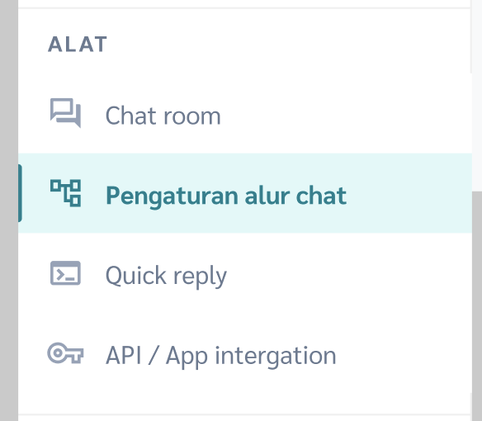  AC2  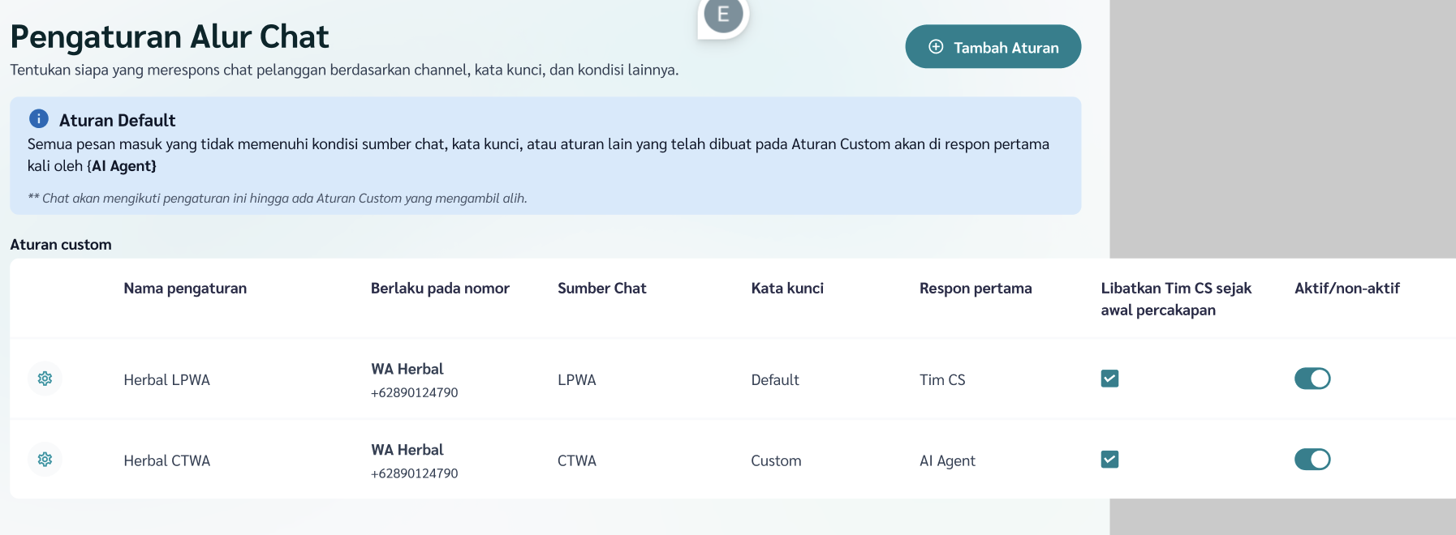
2 | As an owner/supervisor, I want to evaluate all my chat configurations in one place: “chat flow/automation” | AC1 [Chat Flow] Primary default flow (Source = default, Keyword = default) initial condition  Given I have just finished onboard new number “123” and have not configured anything yet related to that number  Then by default the system will provide “primary default” flow in “chat flow/automation” menu  And the “primary default” flow initial values will be:  - Name: Tim CS default flow  - Phone number: 123  - Source: default  - Keyword: default  - First response: Human agent  - Involve human from the start: yes  - Active: yes  - Response: transfer directly to “primary” division (divisi utama)  And the “primary default” flow can not be modified or deactivated from chat flow/automation menu  And the “primary default” flow can not be deleted  Given phone number “123” is deleted from my account  Then the “primary default” flow will also be deleted  AC2 [Chat Flow] Primary default flow - AI Agent active  Given “AI Agent A” assigned to phone number “123”  When I set the “AI Autoreply (agentic)” toggle to on  Then the “primary default” flow will be overridden by these values:  - Name: AI Agent A default flow  - Phone number: 123  - Source: default  - Keyword: default  - First response: AI Agent  - Involve human from the start: no  - Active: yes  - Response: transfer directly to AI Agent A  And the “primary default” flow can not be modified or deactivated from chat flow/automation menu  And the “primary default” flow can not be deleted  When I set the “AI Autoreply (agentic)”toggle back to off  Then the “primary default” flow will be overridden by these values:  - Name: Tim CS default flow  - Phone number: 123  - Source: default  - Keyword: default  - First response: Human agent  - Involve human from the start: yes  - Active: yes  - Response: transfer directly to “primary” division (divisi utama)  And the “primary default” flow can not be modified or deactivated from chat flow/automation menu  And the “primary default” flow can not be deleted  AC3 [Chat Flow] Prevent different response from the same first trigger combination  Given I am creating new “flow” from “Chat flow” menu  When the newly created “flow B” is assigned with the exact same “first trigger combination” (Phone number AND Source AND Keyword) as existing “flow A” in “Chat flow list”  Then the system will prevent me to save the newly created “flow B” with error message “flow with Phone number X, source Y, and Keyword Z is already exist”  AC4 [Chat Flow] Prioritize source over keyword  Given these chat flows/automations are assigned to phone number “123”  Name Source Keyword  Tim CS default flow (primary default) default default  X default A  Y B default  Z C D  Z default keyword C default  When there is incoming chat with  - Source B  - Keyword A  Then the flow “Y” will be executed  Given these chat flows/automations are assigned to phone number “123”  Name Source Keyword  AI Agent default flow (primary default) default default  X default A  When there is incoming chat with  - Source B  - Keyword A  Then the flow “X” will be executed  AC5 [Chat Flow] Handover probabilities within 1 “chat flow/automation”  Given I am configuring a “chat flow/automation”  When current card is “template”  Then I will be able to select transfer destination to human or AI Agent  When current card is “AI Agent”  Then I will be able to select transfer destination to human Agent  AC6 [Chat Flow] Custom keyword - “Chat flow/automation”  Given I create “chat flow/automation Z” on phone number “123”  And the source is “C”  Then I will be able to toggle on the “use keyword”  And I will be able to input group of keyword that will trigger “chat flow/automation Z”  And I will be able to configure the response  When I click save  Then a new “Chat flow/automation Z” with custom keyword will be created  AC7 [Chat Flow] Custom keyword - “Chat flow/automation” default keyword pair  Given I create “chat flow/automation Z” on phone number “123”  And the source is “C”  And the keyword is custom with value “D”  Then the system will automatically create a default keyword pair for “chat flow/automation Z”  And the initial value will be:  - Name: Z - default keyword  - Phone number: 123  - Source: C  - Keyword: default  - First response: Human agent  - Involve human from the start: yes  - Active: yes  - Response: transfer directly to “primary” division (divisi utama)  When I want to modify “chat flow/automation Z - default keyword”  Then this parameters will be able to be modified  - Response (visual builder)  And these parameters will not be able to be modified directly  - Name  - Phone number  - Source  - Keyword  - Activation status  When I delete chat flow/automation Z  Or when I set chat flow/automation Z custom keyword toggle back to off  Then the “chat flow/automation Z - default keyword” will be deleted  When I set the “chat flow/automation Z” status to active/inactive  Then the “chat flow/automation Z - default keyword” will be updated to the same value  When there is incoming chat with  - Source C  - Keyword E  Then the flow “Z - default keyword” will be executed | AC1, 2, 3, 4    AC5  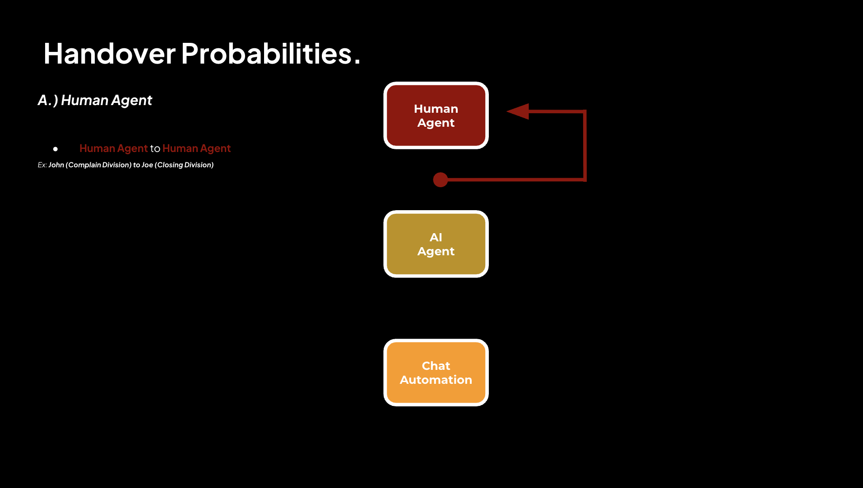  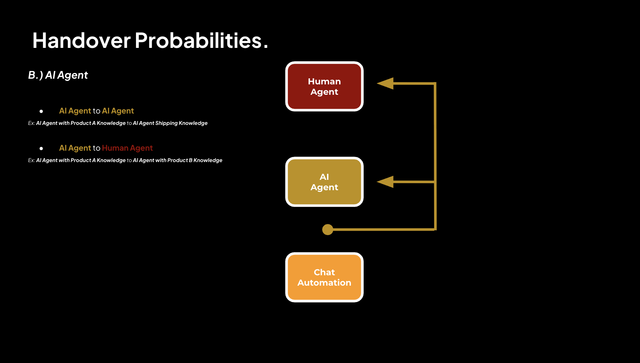  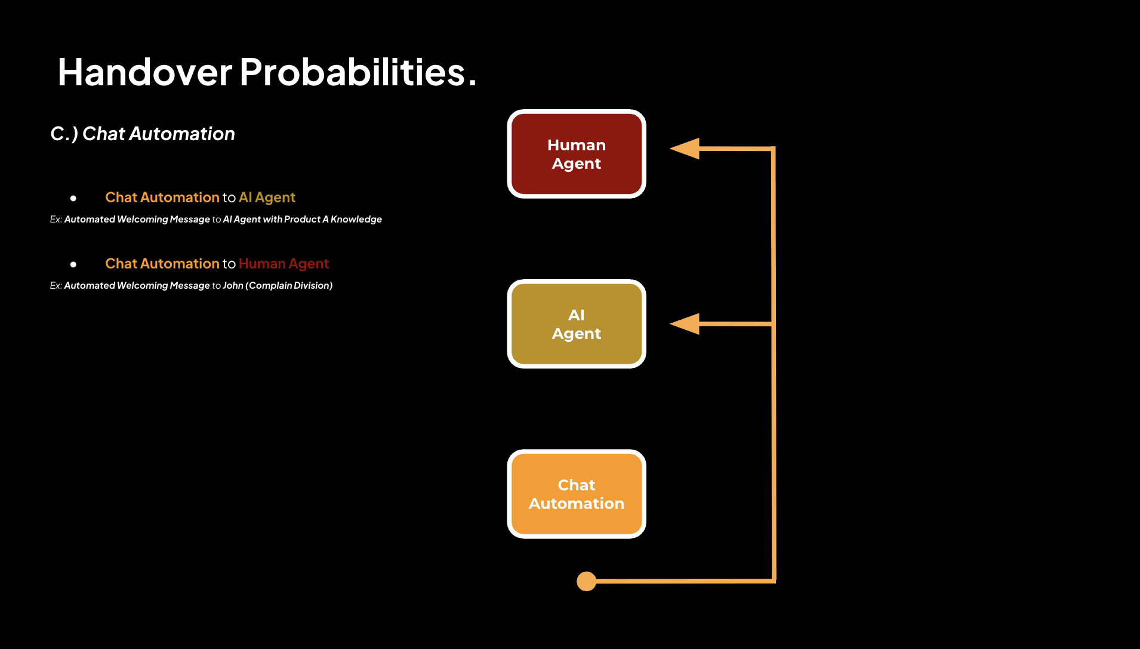  AC6, 7  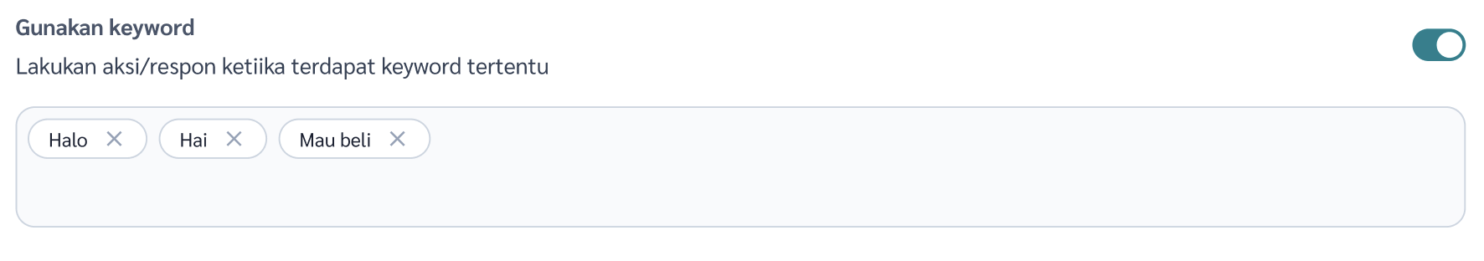
3 | As an owner/supervisor, I want to quickly activate my AI Agent through AI Agent menu without complex setup | AC1 [AI Agent] List of Agents  Given I am an owner/supervisor  When I am on “list of agent” menu  Then I can see “configuration” button on each agent  When I click “configuration” menu  Then I can see agent configuration form with following tabs:  - Basic Info  - Knowledge  - Communication Style  AC2 [AI Agent] Assign one phone number  Given I am an owner/supervisor  When I open one of AI agent configuration “AI agent A”  And click “select Whatsapp number”  Then I can assign “AI agent A” to one of registered phone number  Given “AI agent A” has already assigned to phone number “123”  When I click “select Whatsapp number”  Then I can replace phone number “123” with other phone number  But I can not add multiple phone number  AC3 [AI Agent] System prioritize chat configuration on “Chat Flow/Automation” over “AI agent”  Given in menu “Chat flow/Automation” there is already a listed “chat flow/automation X” assigned to phone number “123” with trigger source “A” and “B”  When I assign “AI agent A” to phone number “123”  And toggle on the “AI Auto-reply (Agentic)” option  Then there is a warning message stating that “New chat with matching conditions will follow the first response defined in “Chat flow/Automation. “AI agent A” can still serve the chat if defined as a transfer destination.”  When there is incoming chat to phone number “123” with source “A” or “B”  Then system will execute response as defined in “chat flow/automation X”  When there is incoming chat to phone number “123” with source “C”  Then the system will assign “AI agent A” to handle the chat | AC1  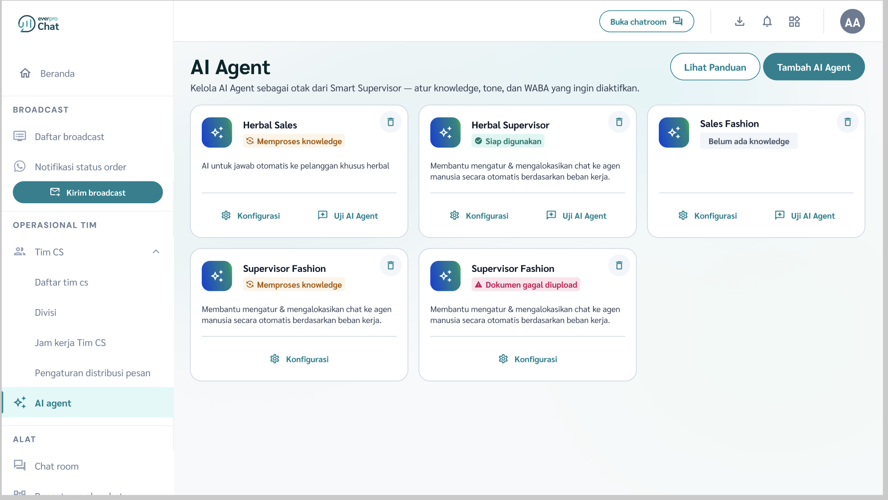  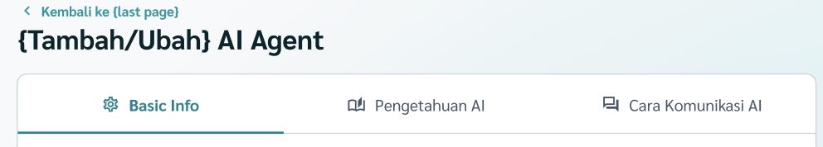  AC2  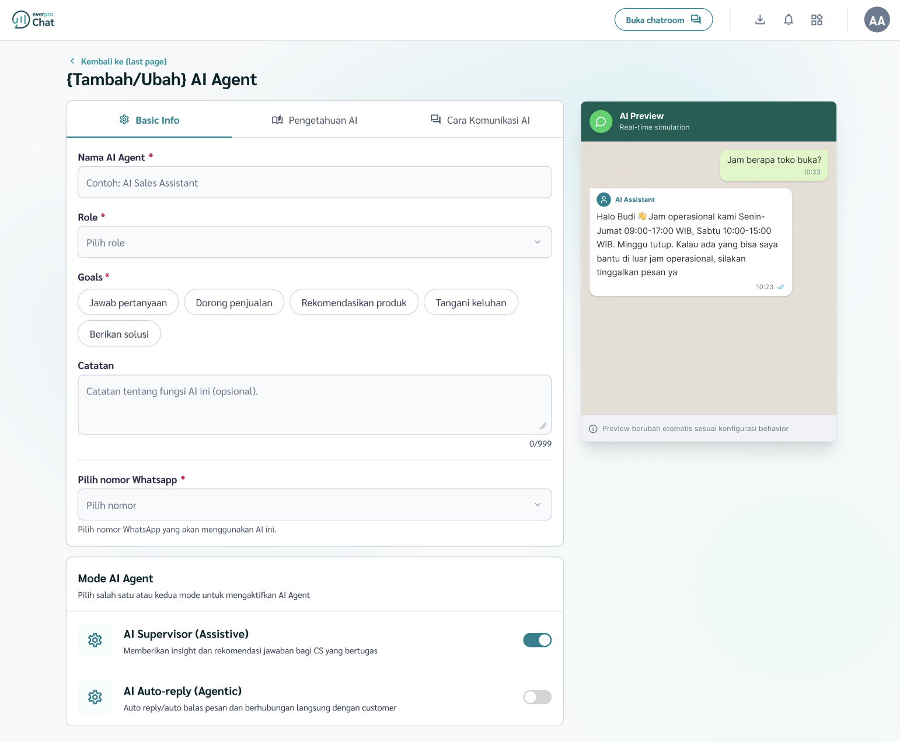  AC3  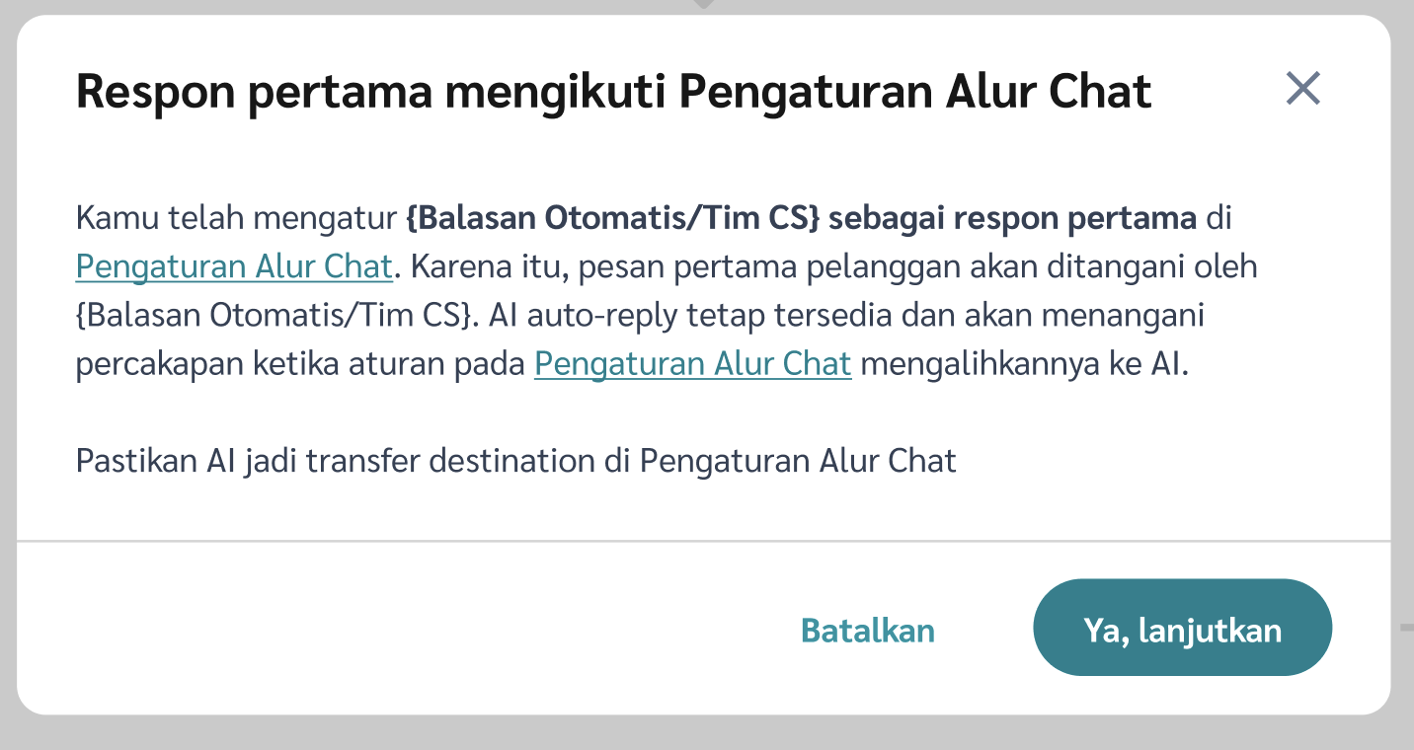
4 | As an owner/supervisor, I want to set transfer condition to human agent from my AI agent | AC1 [AI Agent] AI Agent - Set transfer conditions is mandatory  Given I am an owner/supervisor  And I am on AI Agent configuration menu  When the AI Auto-reply (Agentic) toggle is on  Then the transfer condition section will appear  And I will be required to define intent and handover action to human agent (division or personal)  AC2 [AI Agent] AI Agent - Fallback  Given I am an owner/supervisor  And I am on AI Agent configuration menu  When the AI Auto-reply (Agentic) toggle is on  Then the fallback section will appear  And I will be required to select handover destination when fallback conditions happen:  - Customer chat with undefined intent compared to  - Domain knowledge; and  - Transfer condition intent  - AI service is disrupted  - AI credit exhausted  - AI Repetitive Prevention  - 2x similar response from AI | AC1  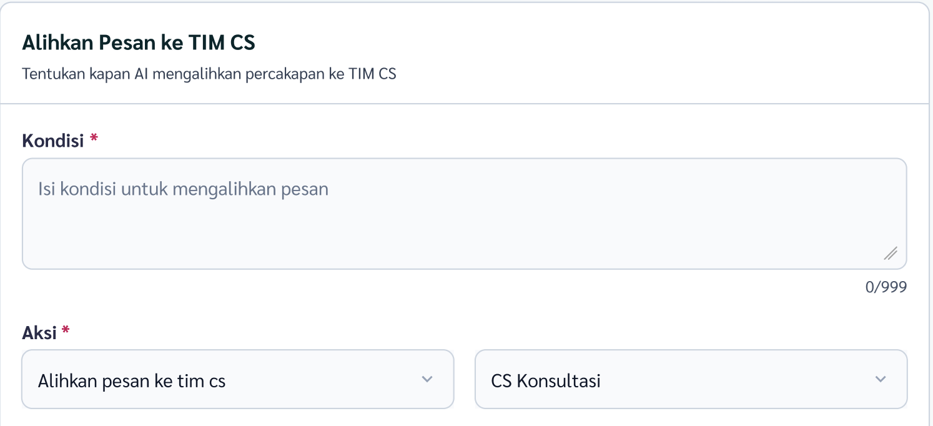  AC2  [tba]
5 | As an owner/supervisor, I want AI Agent settings in “AI Agent” and “Chat Flow” to always show aligned configuration | AC1 [AI Agent -> Chat Flow] Warning when an AI Agent toggle set to off or unassigned from a phone number  Given there is “chat flow/automation X” on phone number “123” with “AI Agent A” involved (as first responder or not)  When I want to set “AI Autoreply (Agentic)” toggle to off in “AI Agent A configuration” menu  Or I want to unassign “AI Agent A” from phone number “123”  Then the system will give me a warning message: “this AI Agent A is involved in chat flow/automation X, continue?”  When I click “yes”  Then the system will allow me to toggle off the AI Agent or unassign AI agent from phone number  And the “chat flow/automation X” will be left as it is (with AI agent still involved but inactive)  AC2 [Chat Flow -> AI Agent] Prevent re-activation a broken chat flow/automation due to AI Agent absence  Given there is a “chat flow/automation X” with status “deactive”  When I want to activate the “chat flow/automation X”  Then the system will check the flow integrity first  When any of these conditions occurs:  - The chat flow involves an inactive AI Agent  - The chat flow involves an AI Agent that its phone number assignment has been removed  Then the system will prevent the automation to be reactivated  And an error message indicating the reason will appear | AC1, 2    AC3  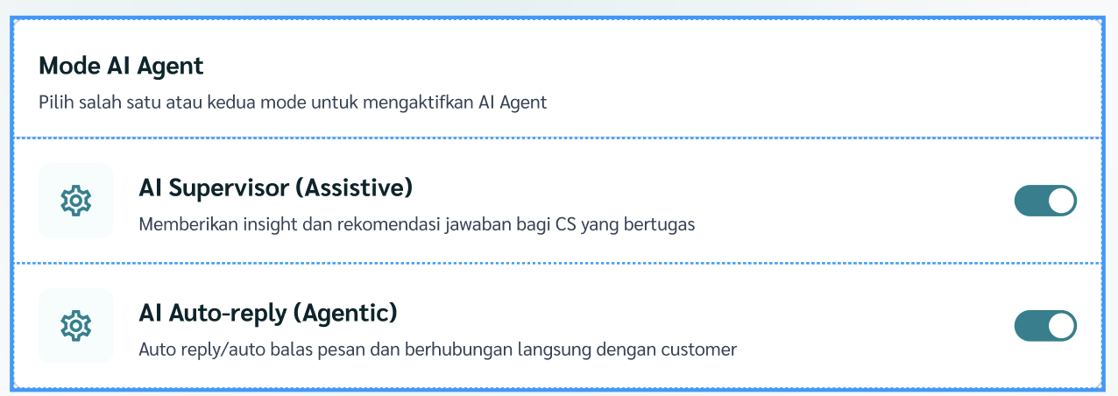
6 | As an owner/supervisor, I want to access the new rearranged human agent menu so that I can get clarity of the feature functions | AC1 [Human Agent Menu Group] Show Daftar Agen submenu under Human Agen/ Tim CS menu  Given I am an owner/supervisor  When I open the “Human Agent/Tim CS”menu  Then I can see the submenus  - Daftar Tim CS  - Divisi  - Jam kerja  - Pengaturan distribusi pesan  AC2 [Distribution Management] Rename menu and preserve existing users’ configuration  Given I have existing distribution configuration (sticky, idle, distribution proportion)  When the changes deployed  Then I can see the menu name has changed from “Pengaturan Chat Masuk” to “Pengaturan Distribusi Pesan”  And my previous distribution configuration will remain unchanged | AC1  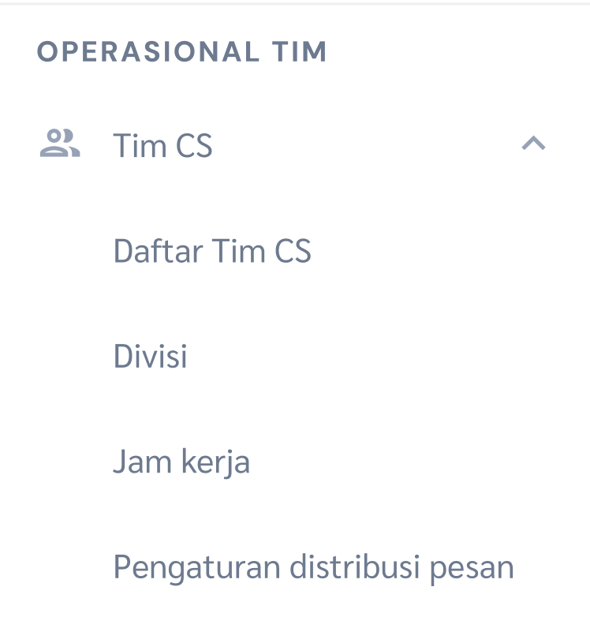  AC2  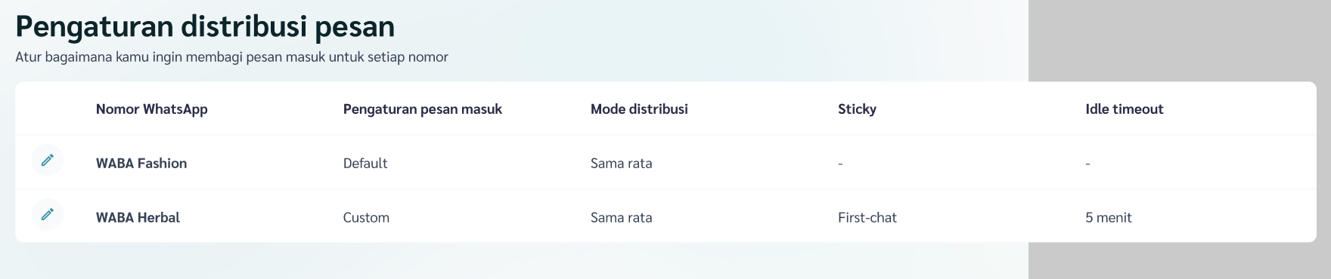
7 | As an owner/supervisor, I want Human Agent setting aligned with chat flow/orchestration menu | AC1 [Human Agent & Chat Flow] Keyword distribution configured in “chat flow/automation” form instead of in “distribution” menu  Given I am an owner/supervisor  And I am on “Tim CS - Pengaturan distribusi pesan” menu for phone number “123”  When I want to configure distribution to division based on keyword  Then I will be redirected to “chat flow/automation” menu  And new “chat flow/automation” form will be opened  And following parameters will have been prefilled and will not be able to be modified:  - WABA/phone number: “123”  And I can configure:  - Source  - List of keyword  - Response  When I click “save”  Then a new “chat flow/automation” will be created according to my configuration  And the “Source” of the new “chat flow/automation” will be “default”  And the “Keyword” of the new “chat flow/automation” will be “custom”  AC2 [Human Agent & Chat Flow] Handle previously saved “distribution” data after changes deployed  Given I have saved 5 pairs of custom distribution (keyword group vs division target pairs)  When the new “chat flow/automation” journey deployed  Then on my “chat flow/automation” list there will be 5 “chat flows/automations” representing my previously with following values:  - Name: “CS Custom distribution [n]” n=1, 2, 3, 4, 5  - Source: default  - Keyword: custom  And each keyword group - division pair will be mapped to each “chat flows/automations”  AC3 [Human Agent & Chat Flow] Updated distribution menu if keyword distribution active  Given there is a “chat flow/automation” other than primary default on phone number “123”  When I open “distribution” menu for phone number “123”  Then the system will show that “distribution custom” is active  Given there is no “chat flow/automation” other than primary default  When I open “distribution” menu  Then the system will show that “distribution default” is active | AC1 - Initial condition  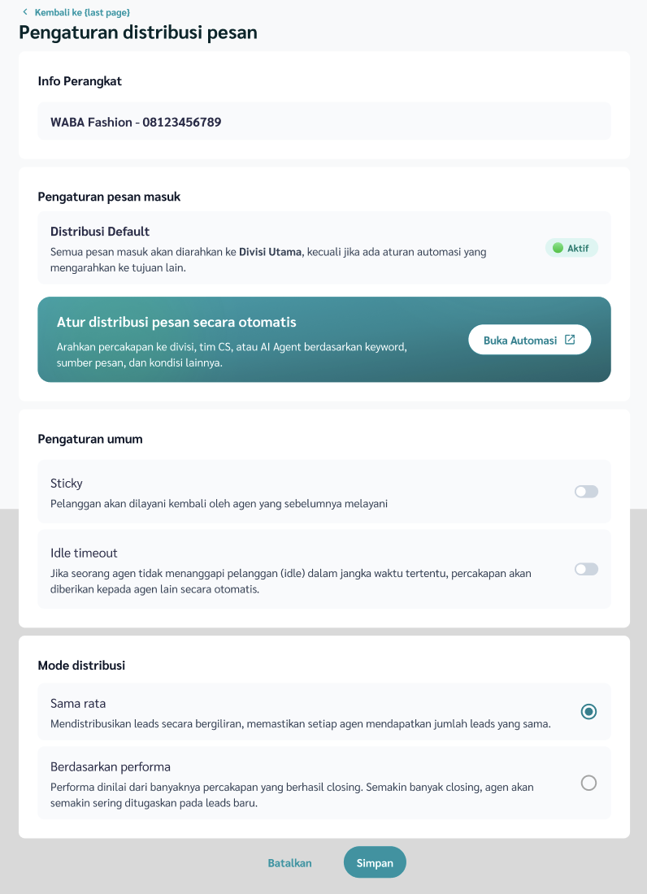  AC1 - After click “Buka Automasi”  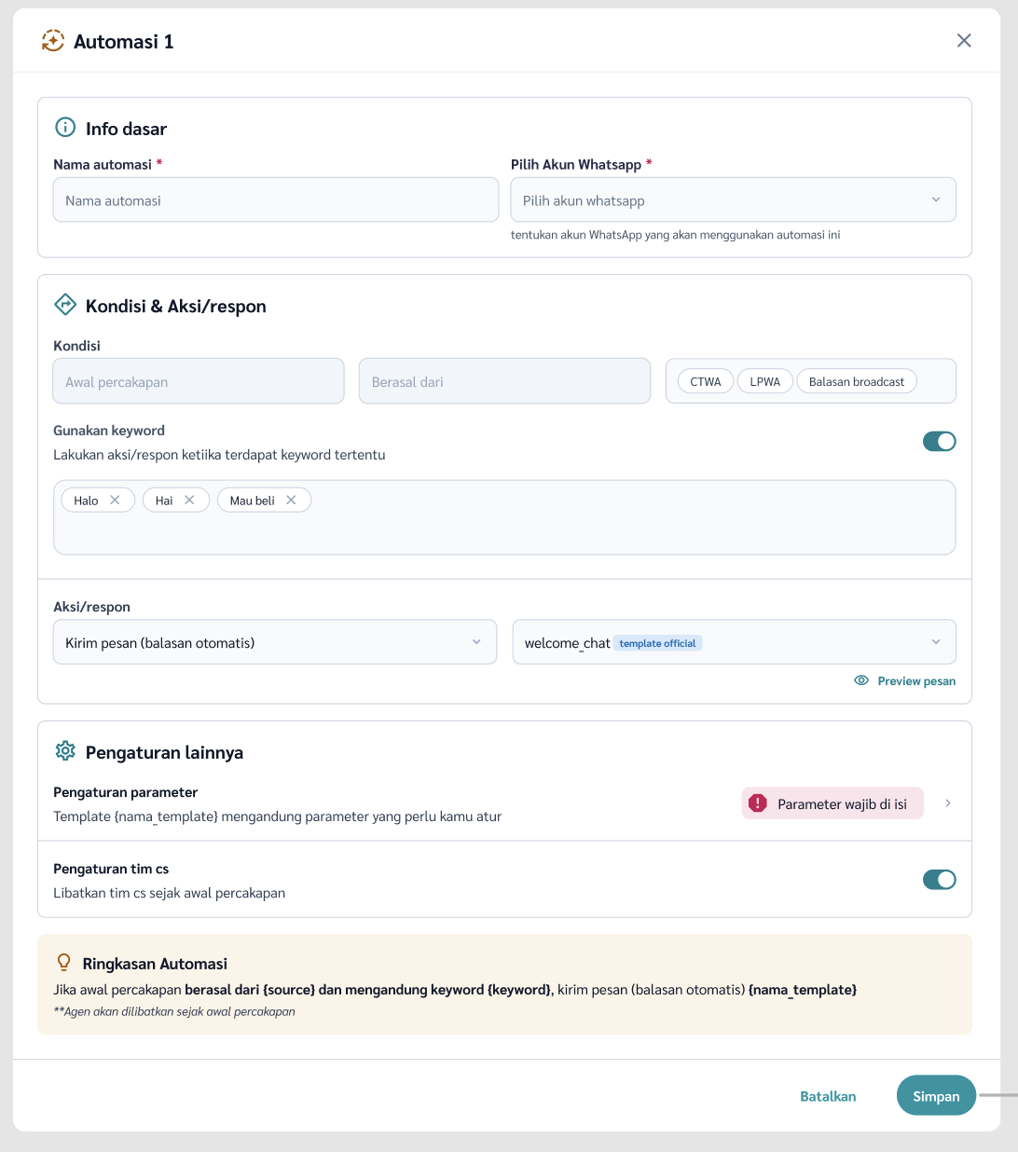  AC3  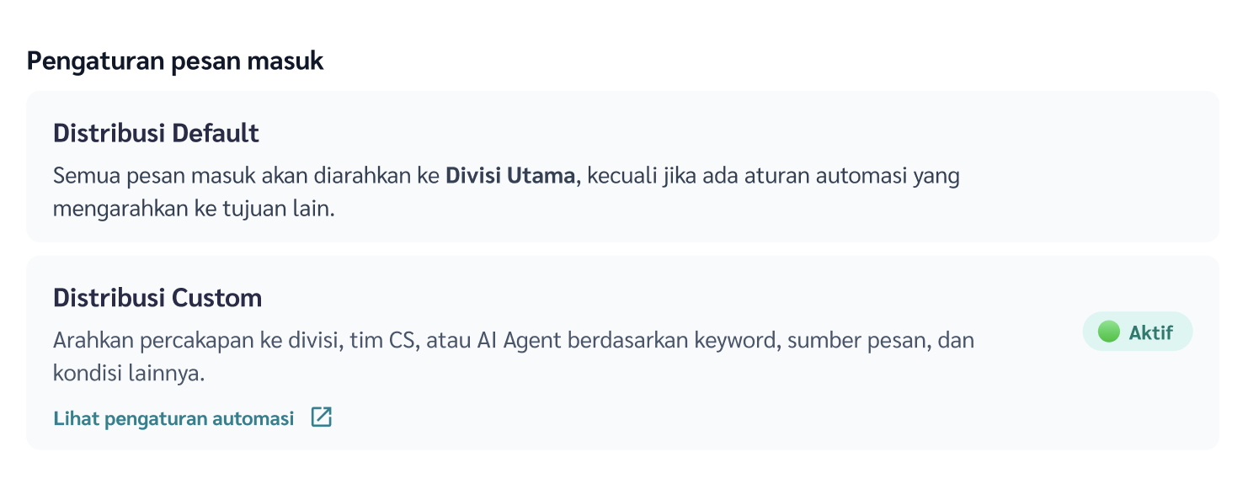
8 | As an owner/supervisor, I want to configure handover from Chat Automation template to AI Agent through the Chat Flow visual builder, so that template-based conversations can continue to the right AI Agent. | AC1 [Chat Flow] Show AI Agent handover option from template card  Given I am an owner/supervisor  When I open the Chat Flow menu  And I select a template card in the visual builder  Then I can see an option to handover the conversation to AI Agent  And I can choose whether to handover to:  - New AI Agent card  - Existing AI Agent card  And the handover configuration is managed from the Chat Flow visual builder  AC2 [Chat Flow] Handover from template to new AI Agent card  Given I am an owner/supervisor  And I select a template card in the Chat Flow Visual Builder  When I choose to handover to a new AI Agent card  Then the system will call AI Agent creation form from in the Chat Flow Visual Builder  And I can configure name, role, goals, description, transfer condition, and fallback  But I will not be able to change phone number or switch toggle AI Auto-reply (agentic) to“ off  When I click save  Then the new AI Agent card will be connected as the next destination after the selected template card  And I can configure the required AI Agent settings from the new AI Agent card  And the connection is saved as part of the Chat Flow configuration  AC3 [Chat Flow] Handover from template to existing AI Agent card  Given I am an owner/supervisor  And there is at least one existing AI Agent card in the Chat Flow Visual Builder  When I select a template card  And I choose to handover to an existing AI Agent card  Then I can select one existing AI Agent card as the handover destination  And the system connects the selected template card to the selected AI Agent card  And the system does not create a duplicate AI Agent card  And the connection is saved as part of the Chat Flow configuration  AC4 [Chat Flow] Execute handover from template to AI Agent  Given a customer conversation is currently handled by a Chat Automation template  And the template has AI Agent as the configured next destination  When the conversation reaches the configured handover point  Then the system transfers the conversation to the selected AI Agent card  And the selected AI Agent continues the conversation using the available conversation context  And the Chat Automation template stops running for that conversation  And the active handler status is updated in the Chat Room  AC5 [Chat Flow] Prevent inactive AI Agent handover destination  Given I am an owner/supervisor  When I configure template handover to AI Agent  And I select “existing AI Agent”  And the selected existing “AI Agent A” is inactive  Then the system will give warning “this action will activate AI Agent A, continue?”  When I click “Yes”  Then the system will force “AI Agent A” status to “active”  And I will be able to save the configured chat flow | AC1  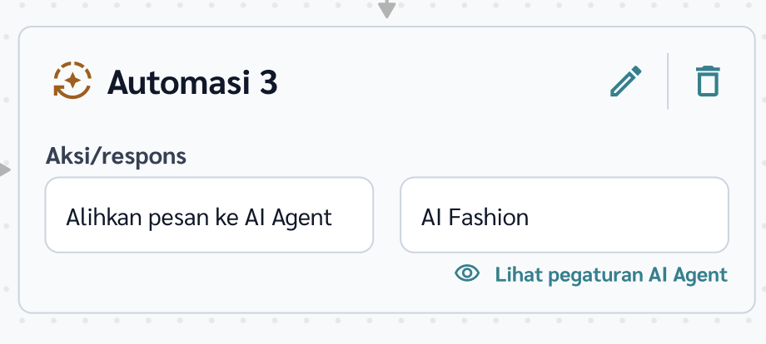  AC2  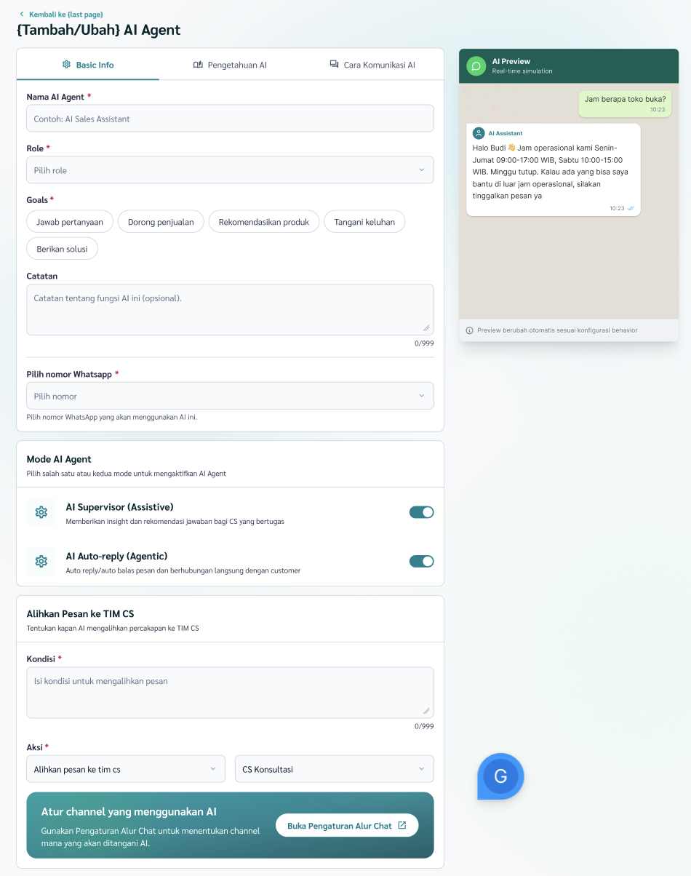
9 | As an owner/supervisor/agent, I want messages from Template, AI Agent, and Human Agent to have different bubbles in the Chat Room, so that I can clearly identify who or what sent each message in a conversation. | AC1 [Chat Room] Show different bubble for Template message  Given I am an owner/supervisor/agent  When I open a conversation in Chat Room  And the conversation contains a message sent by Template  Then the system shows the message using the Template bubble style  And the message clearly indicates that it was sent by Template  And the Template bubble is visually different from AI Agent and Human Agent bubbles  AC2 [Chat Room] Show different bubble for AI Agent message  Given I am an owner/supervisor/agent  When I open a conversation in Chat Room  And the conversation contains a message sent by AI Agent  Then the system shows the message using the AI Agent bubble style  And the message clearly indicates that it was sent by AI Agent  And the AI Agent bubble is visually different from Template and Human Agent bubbles  AC3 [Chat Room] Show different bubble for Human Agent message  Given I am an owner/supervisor/agent  When I open a conversation in Chat Room  And the conversation contains a message sent by Human Agent  Then the system shows the message using the Human Agent bubble style  And the message clearly indicates that it was sent by Human Agent  And the Human Agent bubble is visually different from Template and AI Agent bubbles  AC4 [Chat Room] Show sender information in message bubble  Given I am an owner/supervisor/agent  When I view messages in Chat Room  Then each outgoing message bubble shows the sender type  And the sender type can be:  - Template  - AI Agent  - Human Agent  When the message is sent by AI Agent  Then the bubble can show the AI Agent name  When the message is sent by Human Agent  Then the bubble can show the Human Agent name  AC5 [Chat Room] Keep customer message bubble unchanged  Given I am an owner/supervisor/agent  When I open a conversation in Chat Room  And the conversation contains messages from the customer  Then the customer message bubble remains unchanged  And the customer message bubble is visually different from Template, AI Agent, and Human Agent bubbles  AC6 [Chat Room] Preserve bubble type in conversation history  Given a conversation has messages sent by Template, AI Agent, or Human Agent  When I reopen the conversation history  Then the system still shows the correct bubble type for each message  And the sender type does not change after the conversation is transferred to another handler | AC1, 2, 3, 4, 5  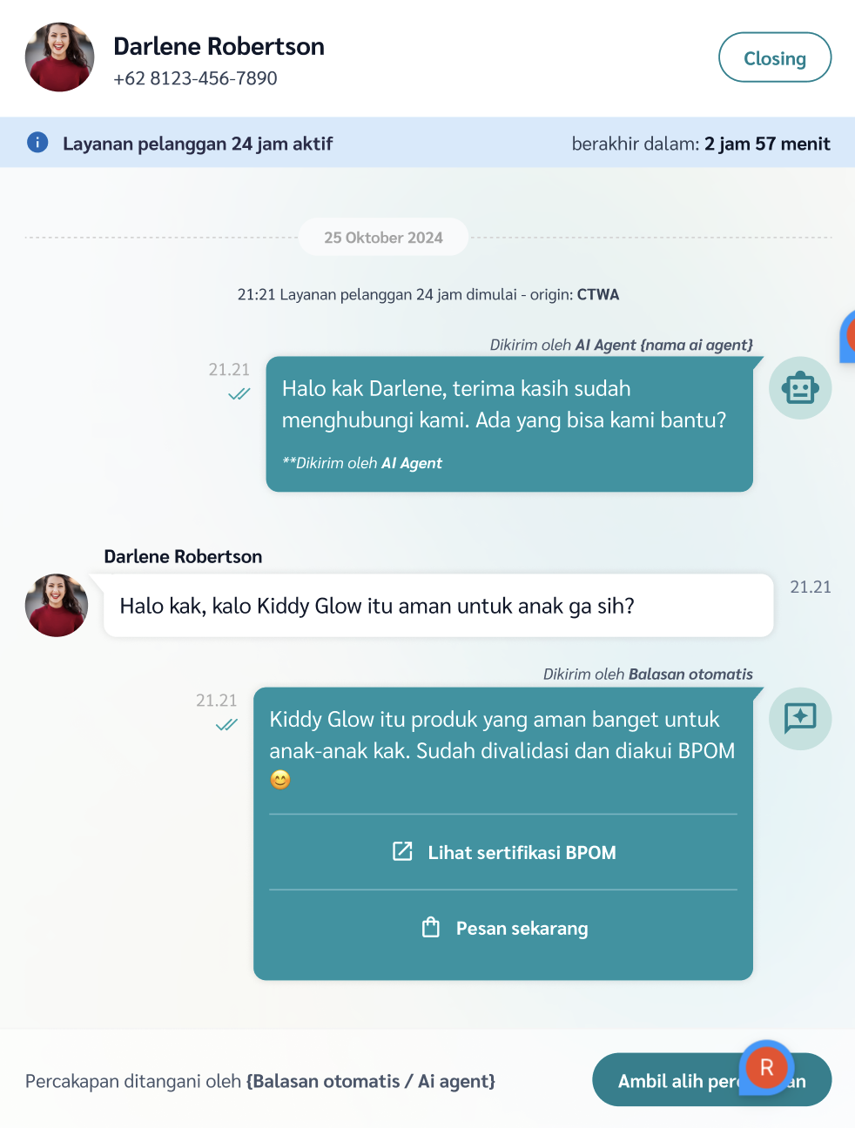
10 | As an owner/supervisor/agent, I want to take over the active AI Agent/ automation for a specific conversation from the Chat Room, so that I continue the conversation manually when needed | AC1 [Chat Room] Show turn off flow action for active Chat Flow conversation  Given I am an owner/supervisor/agent  And a conversation is currently handled by an active Chat Flow  When I open the conversation in Chat Room  Then I can see an action to turn off the flow for that conversation  And the action is only available for users with permission to manage the conversation  AC2 [Chat Room] Turn off flow for selected conversation  Given I am an owner/supervisor/agent  And a conversation is currently handled by an active Chat Flow  When I click the turn off flow action within the Chat Room  Then the system turns off the active Chat Flow for that specific conversation  And the flow stops sending automated responses for that conversation  And the flow stops moving the conversation to the next card in the Chat Flow  And the conversation remains visible in Chat Room  AC3 [Chat Room] Allow Human Agent to handle conversation after flow is turned off  Given the active Chat Flow has been turned off for a conversation  When I open the conversation in Chat Room  Then a Human Agent can reply manually to the customer  And the automated handler does not respond again in that conversation  And the active handler status is updated in Chat Room  AC4 [Chat Room] Prevent automated trigger after flow is turned off  Given the active Chat Flow has been turned off for a conversation  When the customer sends a new message that matches an automation, AI Agent, or handover condition  Then the system does not trigger the turned off flow again for that conversation  And the conversation remains under manual handling of an Human Agent  AC5 [Chat Room] Hide overlay button after takeover  Given I have taken over a conversation from AI Agent  When the takeover is completed  Then the Ambil Alih Chat button is no longer shown for that conversation  And the conversation can be handled manually by Human Agent  And the Human Agent is able to type within the Chat Room  And the AI Agent/automation template does not continue responding | AC1, 2, 3, 4, 5  